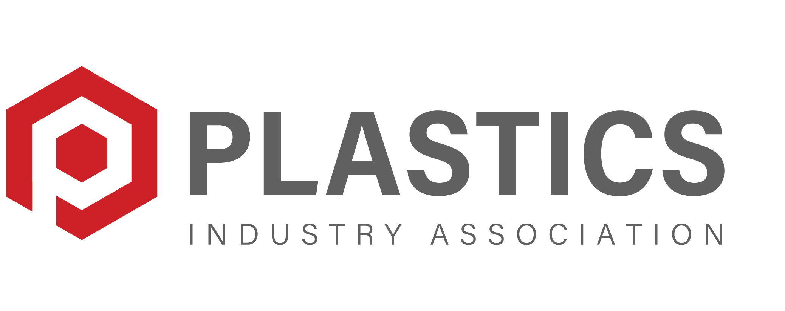
Application for Membership in PLASTICS Standards Committees

PLASTICS’ Standards Committees are made up of industry experts who identify the need, then develop, approve, and revise standards and other technical publications. New projects must be justified by valid business and safety needs. The standards-writing groups are open to representatives of organizations that are materially affected by the documents.

Please return completed form* to:
Jennifer Jones
Director, Industry Standards, Plastics Industry Association
Email: jjones@plasticsindustry.org

Organization
Organization Name
Address
Address #2
City/State/Zip
Phone
website
Interest Category (see attached for descriptions) |  |  | Choose from this drop down

Member (Person to be designated as principal representative)
Name
Title
Phone |  |  |  | Email

Organization or individual qualification/expertise applicable to standards development:

Alternate [Additional person(s) to be added to distribution as observers (optional)]
Name
Title
Phone |  |  |  | Email
Which PLASTICS committee would you like to join? (check all that apply)
☐ Extrusion ☐ Injection Molding Machines ☐ Blow Molding ☐ Auxiliary Components ☐ Other

PLASTICS Standards Interest Categories:

Interest Category | Definition
Manufacturer | A company or organization that produces the product (e.g., molding machines) covered by this standard.
Other Producer | A company or organization predominantly involved with manufacturing, marketing or supplying products (e.g., molds, electronic components or electronic systems) or materials (e.g., plastic resin) related to (e.g., used with or incorporated into) the product (e.g., molding machines) covered by the standard (but not the product covered by the standard).
User | A company or organization that uses the product covered by the standard in an industrial environment (e.g., a factory or manufacturing facility.)
Trade Association | An organization founded and funded by businesses that operate in a specific industry. An industry trade association participates in public relations activities such as advertising, education, political donations, lobbying and publishing, but its main focus is collaboration between companies, or standardization. Associations may offer other services, such as producing conferences, networking or charitable events or offering classes or educational materials. Many associations are non-profit organizations governed by bylaws and directed by officers who are also members.
Distributor | A company or organization that distributes a related commodity at either wholesale and/or retail prices.
Government Agency | A permanent or semi-permanent organization in the machinery of government that is responsible for the oversight and administration of specific functions.
Professional Society | A non-profit organization (typically) seeking to further the interests of a particular profession, the interests of individuals engaged in that profession, and the public interest.
Insurance | A company, organization or industry that provides coverage by contract whereby one party undertakes to indemnify or guarantee another against loss by a specified contingency or peril.
Labor | An organization of workers who have banded together to achieve common goals such as better working conditions. Labor, through its leadership, bargains with the employer on behalf of union members and negotiates labor contracts (collective bargaining) with employers. This may include the negotiation of wages, work rules, complaint procedures, rules governing hiring, firing and promotion of workers, benefits, workplace safety and policies. The agreements negotiated by the union leaders are binding on the rank and file members and the employer, and in some cases, on other non-member workers.
Other | An entity not adequately covered by any of the above interest categories (e.g., consultants, testing laboratories etc.).

*NOTE: This form may be circulated to the members of the appropriate consensus body for review. This application to and participation in this committee constitutes waiver as an individual member/company of copyright of any standards or materials produced by the committee.

